PRESS RELEASE, March 2018

Institute of Industrial Design, Academy of Art and Design, FHNW in Basel presents at Salone Satellite 2018:

A collaboration between RIBAG and Industrial Design Institute at the Academy of Art and Design in Basel

"Poetry of Light" - new ideas for mobile light

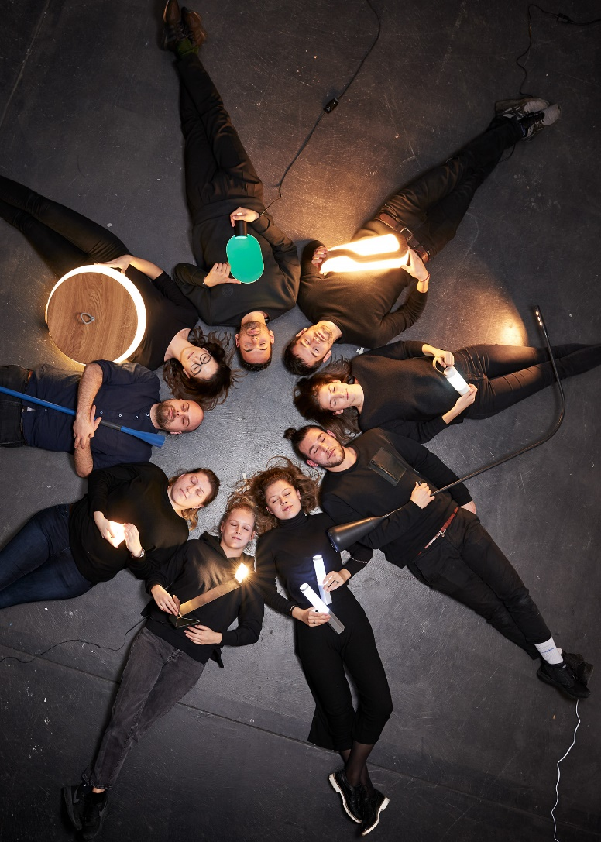
Swiss-based lighting manufacturer RIBAG has been working in collaboration with the Industrial Design BA students of the Institute Industrial Design, Academy of Art and Design FHNW in Basel to develop prototypes of future light fittings and concepts for the subject of "mobile light". Eight prototypes had been selected for being displayed at the prestigious Salone Satellite during the Salone del Mobile in Milan in April 2018.

Project leaders: Nicole Schneider (senior lecturer) and Werner Baumhakl (professor/head of the Institute)
Partners RIBAG Licht AG: Andreas Richner, (CEO / owner) and Pascal Amacker, (Creative Director - Design and Development)

"A house is only inhabitable when it is filled with light and air," said the iconic Swiss architect and designer - Le Corbusier. Following his thoughts, the students analyzed the intimate connection between light and dwell, striving to develop solutions that not only focus on the technological potential of a light fitting, rather on the formal quality of a luminaire.

“Poetry of Light” is represented by eight selected high-end prototypes. The students' conceptual ideas are diverse and hallmarked with a very personal view of the mobile light. The range of concepts encloses e.g. a contemporary interpretation of a traditional Japanese
lampion, a torch for elderly people, an unconventional "lantern" inspired by Swiss alpine chalets and flexible home-office solutions.

Exhibition “Poetry of Light”
Date: 17-22 April 2018,
Place: Salone Satellite, Pavilion 13-15, Stand no. S15
Opening hours: 09:30 am – 06:30 pm

Please note that we also show the exhibition "Share a chair" at Fuorisalone in BRERA Design district, Via Alessandro 13, 20121 Milano.

Press material:
www.fhnw.ch/hgk-iid-presse

We would appreciate being notified about any publications. Please address a copy to the attention of Barbara Kohler (for the address refer to our imprint)

Imprint

Publisher
Prof. Werner Baumhakl

Copyright
© André Hönicke /
Institut Industrial Design / HGK Basel

Further information on “Poetry of Light”
Fachhochschule Nordwestschweiz FHNW,
Hochschule für Gestaltung und Kunst
Institut Industrial Design
Prof. Werner Baumhakl
Freilager-Platz 1, P.O. Box; CH-4002 Basel
T +41 61 228 40 44
info.industrialdesign.hgk@fhnw.ch

General Media Information
Fachhochschule Nordwestschweiz FHNW,
Hochschule für Gestaltung und Kunst
Jenni Schmitt, Kommunikation
Freilager-Platz 1, P.O. Box; CH-4002 Basel
T +41 61 228 43 52, jennifer.schmitt@fhnw.ch
www.fhnw.ch/hgk / www.campusderkuenste.ch

